# **Receiving Messages form Event Hub**

This demo is about receiving messages from the event hub and storing them inside storage containers in azure. For this we should have event hub service that is fed up with messages. Go through previous demos to create event hub and send messages to it.

**Creating Azure Storage Account:**

Go to **+ Create New resource** and choose **Storage->Storage Account.** Give an unique name, and choose the same location that is given in the image below. Choose a resource group and click on create.

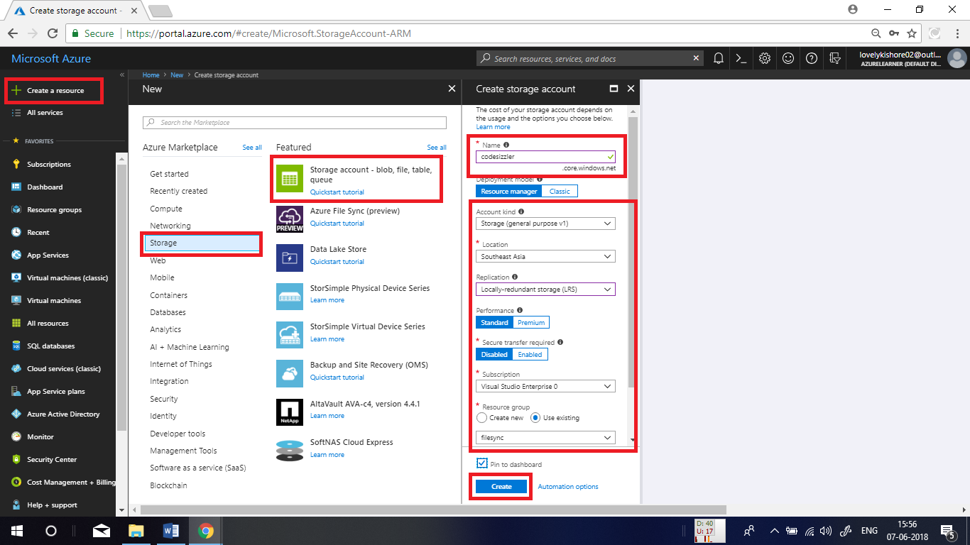

**Creating a Container:**

Now, create a container to copy the data that you are going to copy using pipeline. To do this, go to overview page of the storage account that you created and click on **Blobs.**

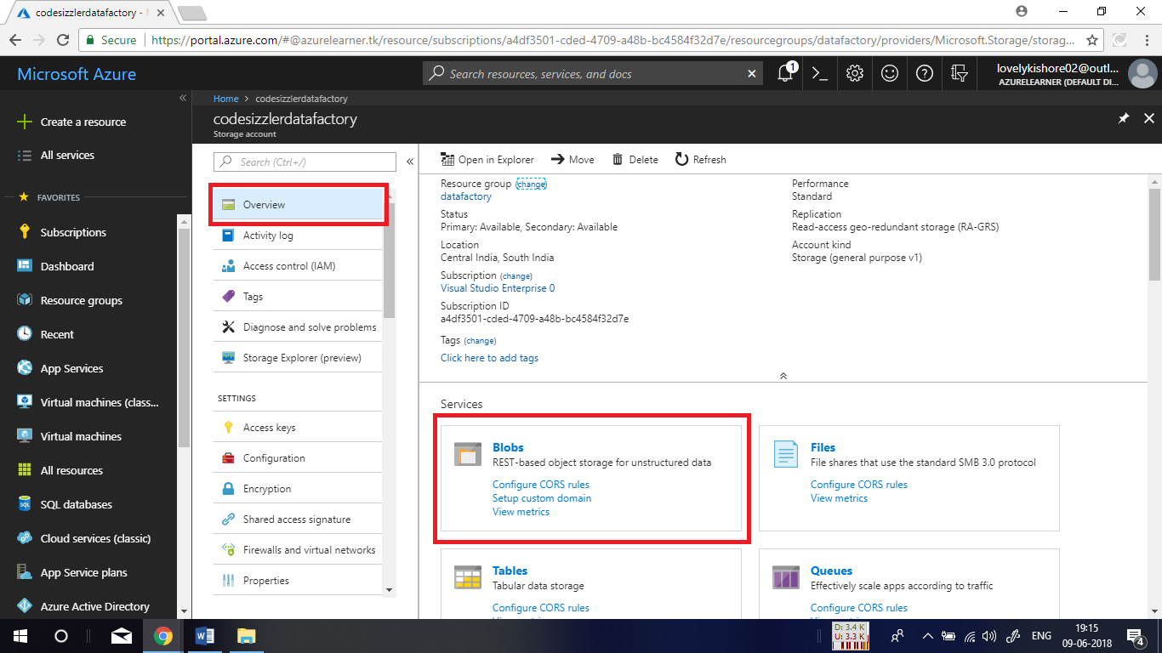

Then click on **+Container** and give a name for the container and click on ok.

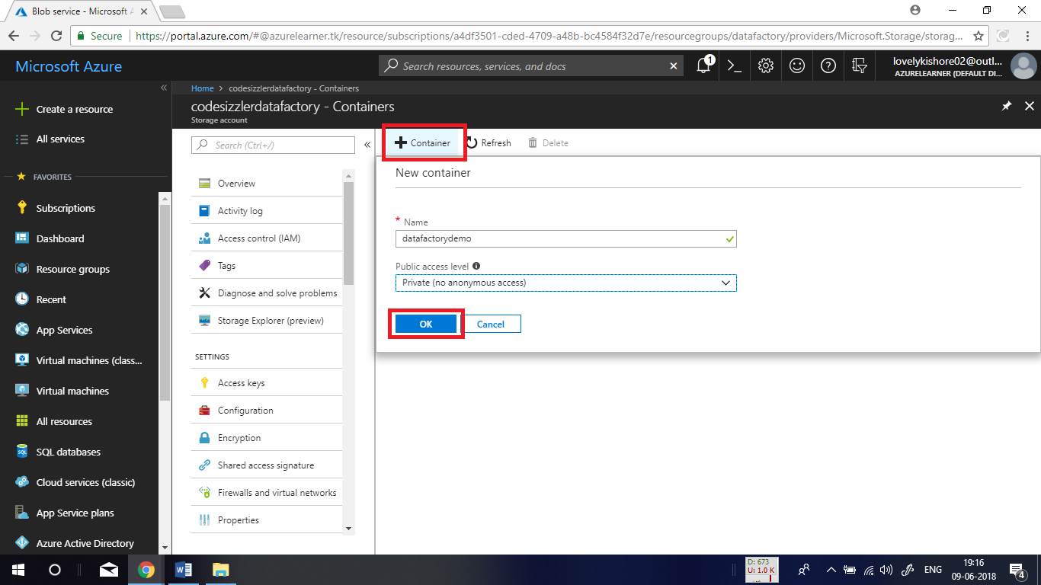

After this, you will be able to find your created container as shown below.

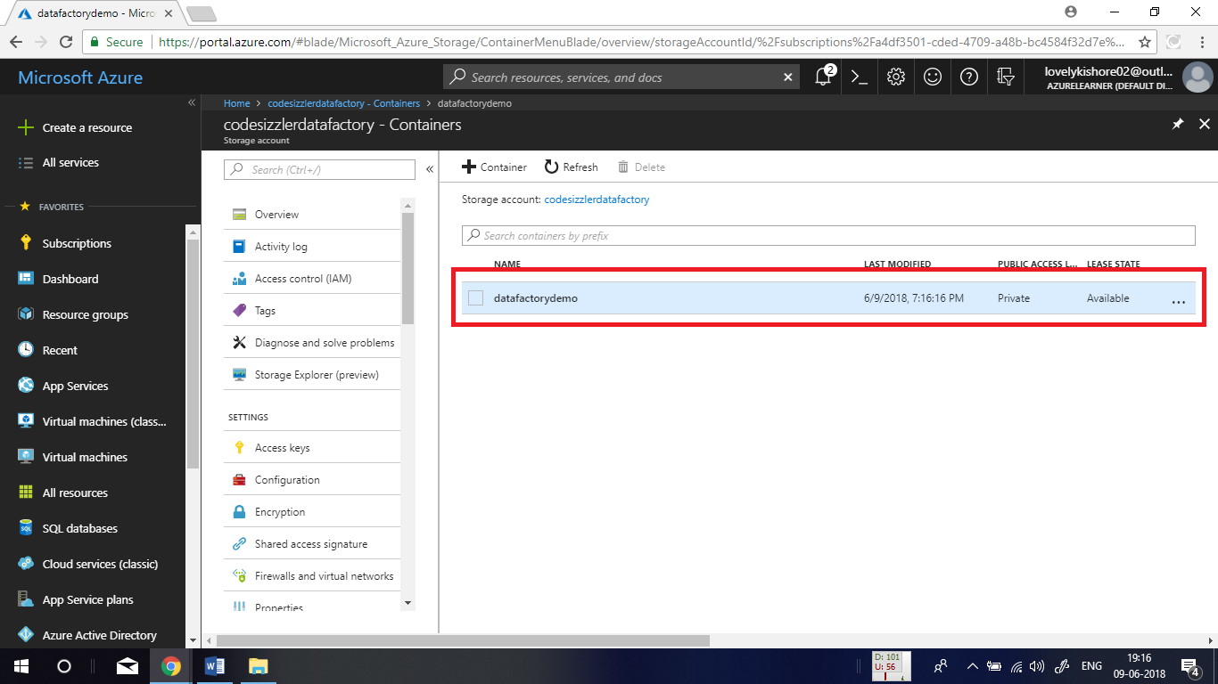

After the container creation is done, go to **Access Keys** menu in the left sidepage of your storage account and copy the **Connection String** as denoted below. Paste it in a notepad to make use of it in the later part.

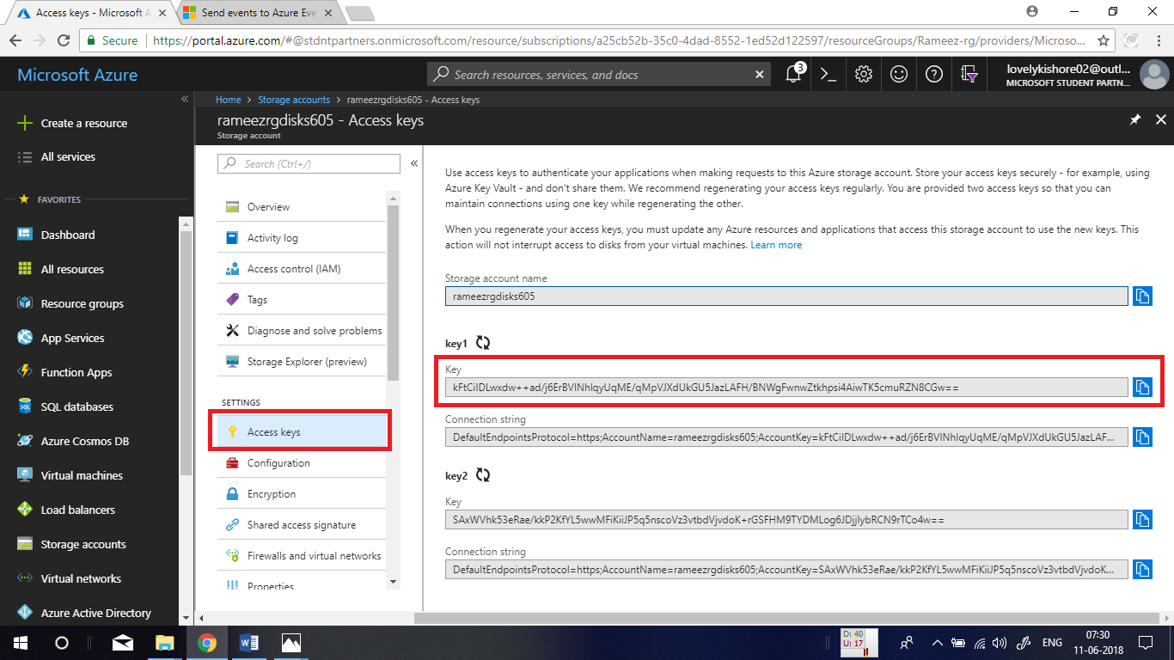

**Creating Application:**

Open visual studio and go to **File -> New -> Project.**

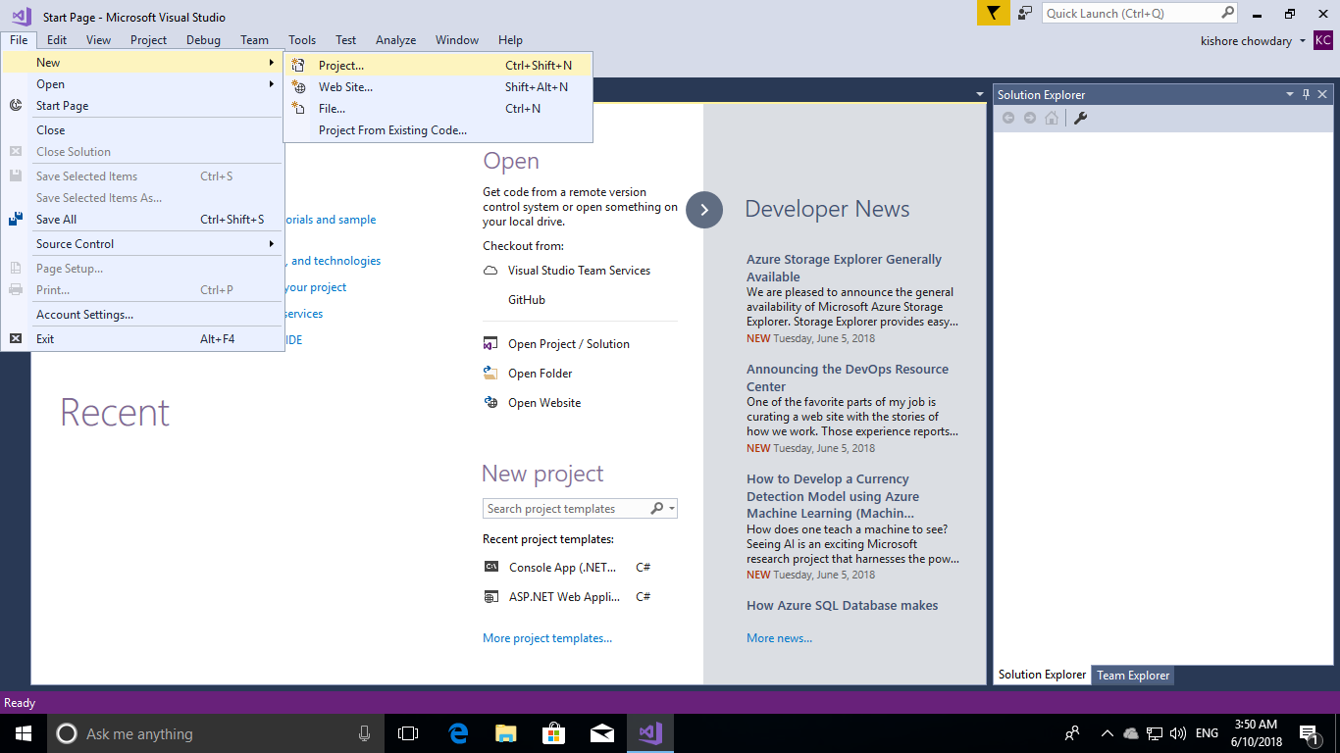

Under **.Net Core** Template, choose **Console App (.Net Core),** name it and click on **Ok.**

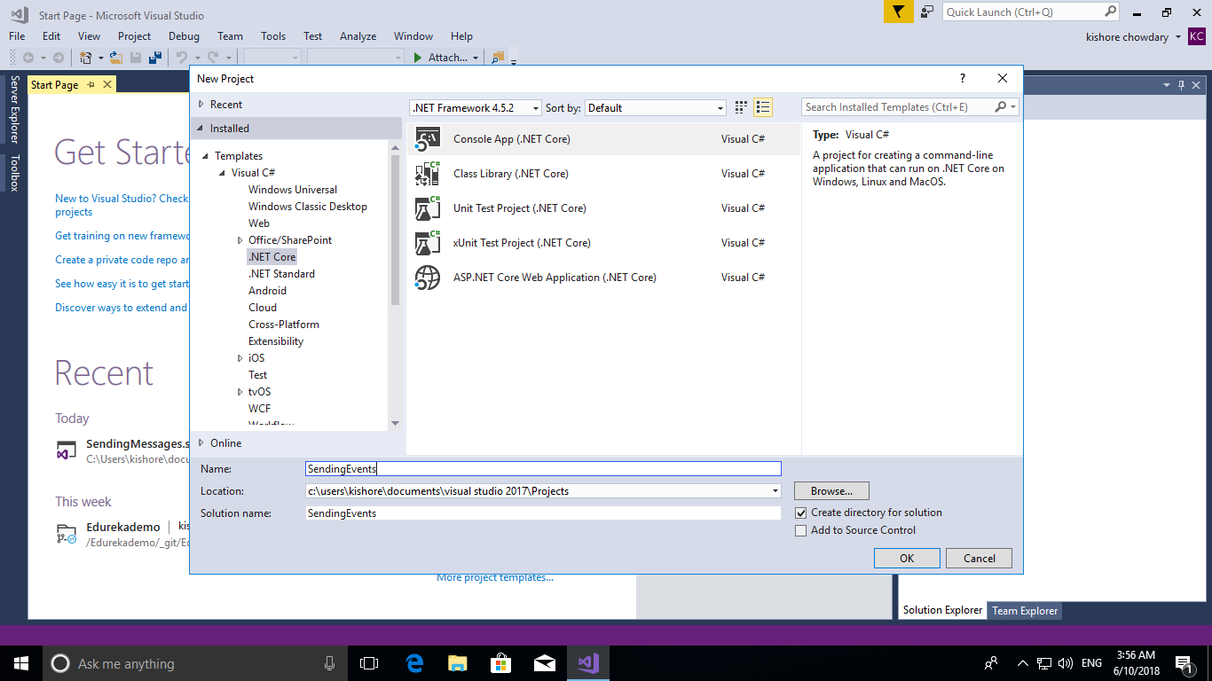

After the solution gets created, right click the solution in the right and click on **Manage NuGet Packages** to add required packages for this demo.

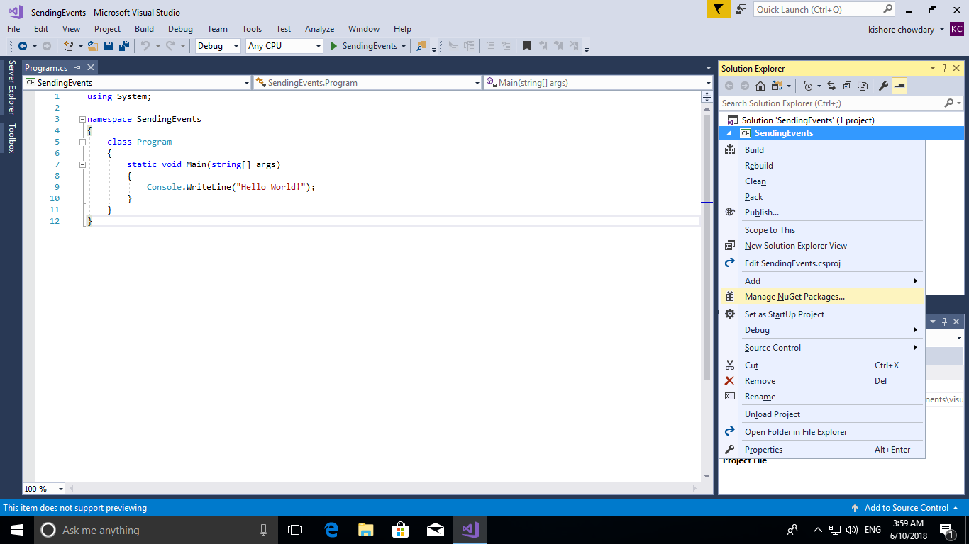

Click on **Browse** and search for **Microsoft.Azure.EventHubs** and hit on **Install.** Accept the terms when prompted during the installation process. Again, search for another package **Microsoft.Azure.EventHubs.Processor** and install the same.

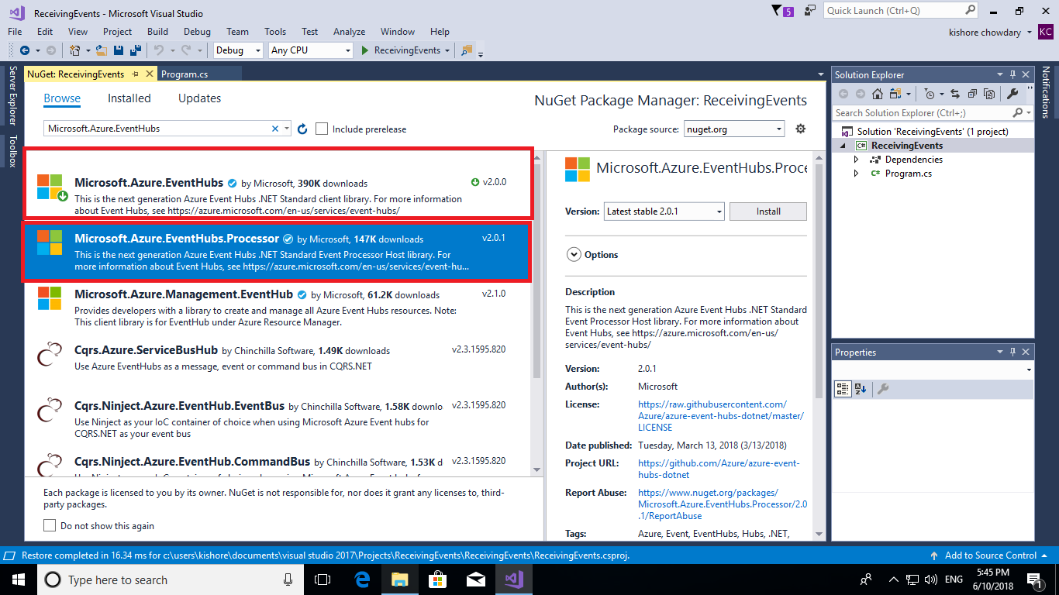

Now, right click the solution and add a class named **SimpleEventProcessor** by going to **Add -> Class.**

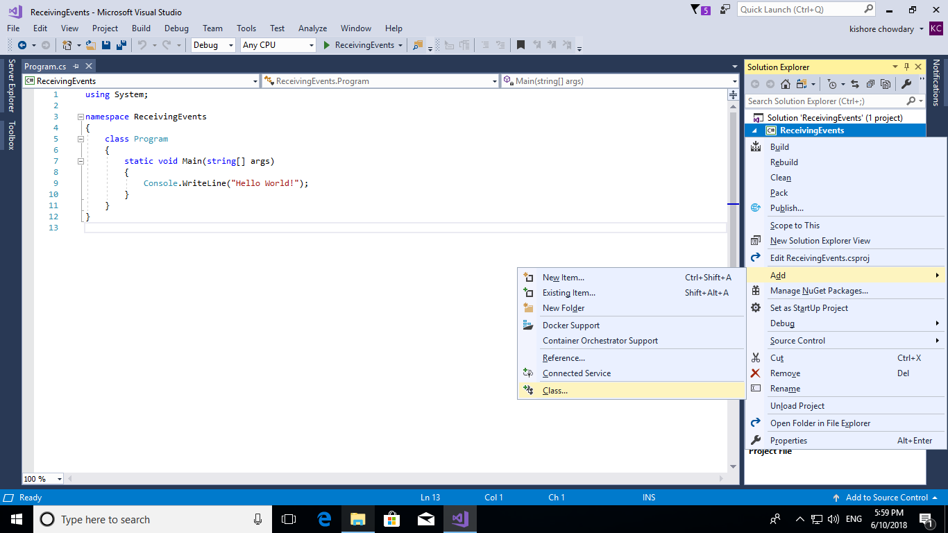

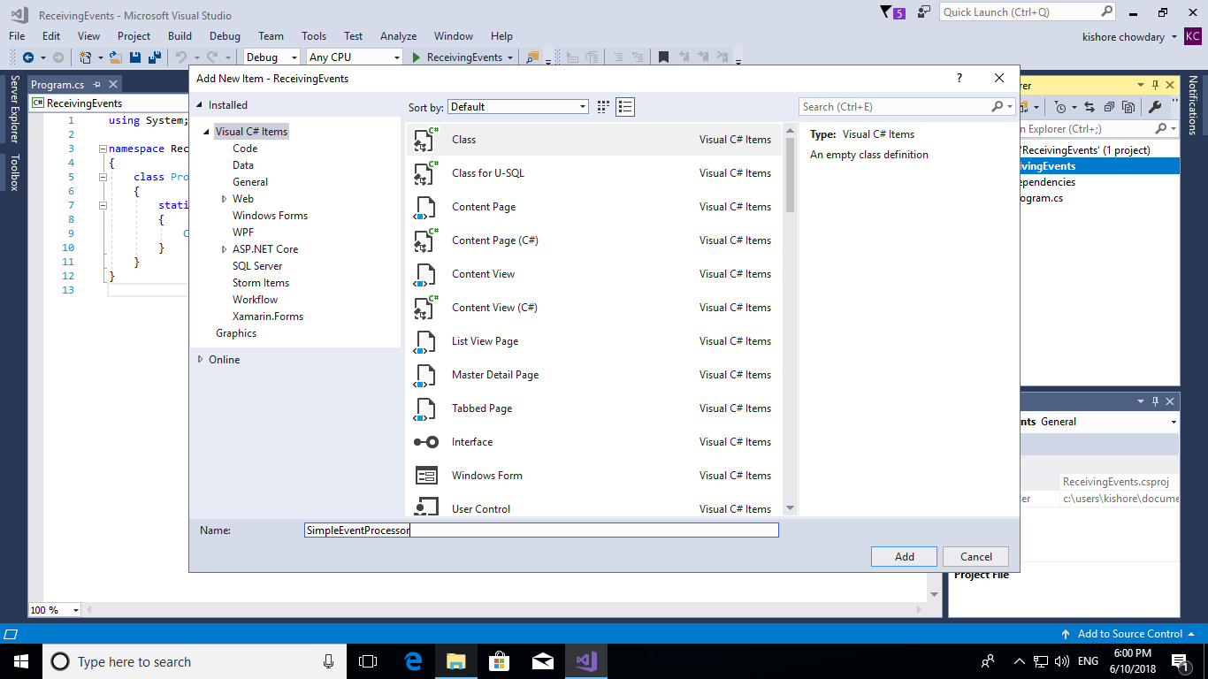

Paste the below given code in your **SimpleEventProcessor** page as shown below.

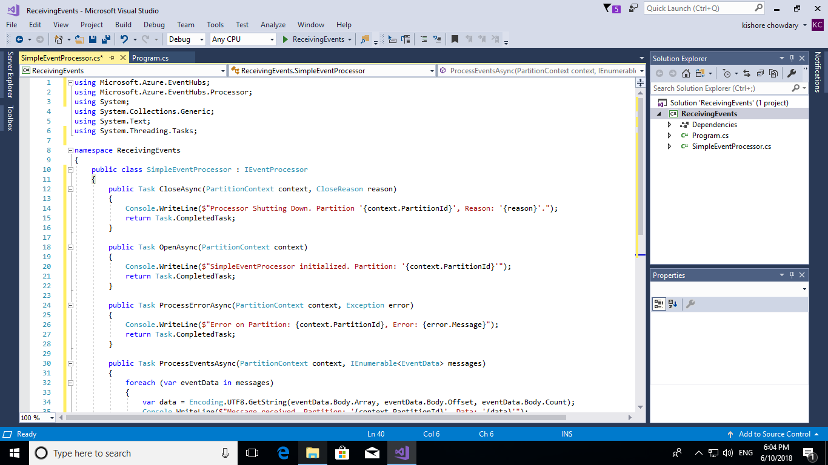

**SimpleEventProcessor.cs:**

using Microsoft.Azure.EventHubs;

using Microsoft.Azure.EventHubs.Processor;

using System.Threading.Tasks;

namespace ReceivingMessages

{

public class SimpleEventProcessor : IEventProcessor

{

public Task CloseAsync(PartitionContext context, CloseReason reason)

{

Console.WriteLine($"Processor Shutting Down. Partition '{context.PartitionId}', Reason: '{reason}'.");

return Task.CompletedTask;

}

public Task OpenAsync(PartitionContext context)

{

Console.WriteLine($"SimpleEventProcessor initialized. Partition: '{context.PartitionId}'");

return Task.CompletedTask;

}

public Task ProcessErrorAsync(PartitionContext context, Exception error)

{

Console.WriteLine($"Error on Partition: {context.PartitionId}, Error: {error.Message}");

return Task.CompletedTask;

}

public Task ProcessEventsAsync(PartitionContext context, IEnumerable<EventData> messages)

{

foreach (var eventData in messages)

{

var data = Encoding.UTF8.GetString(eventData.Body.Array, eventData.Body.Offset, eventData.Body.Count);

Console.WriteLine($"Message received. Partition: '{context.PartitionId}', Data: '{data}'");

}

return context.CheckpointAsync();

}

}

}

Now, Go to the portal and open the event hub that you have created and in the left side menu click on **Shared Access Policies.** In there copy the **Connection String** which is required to connect our application to receive message from event hub.

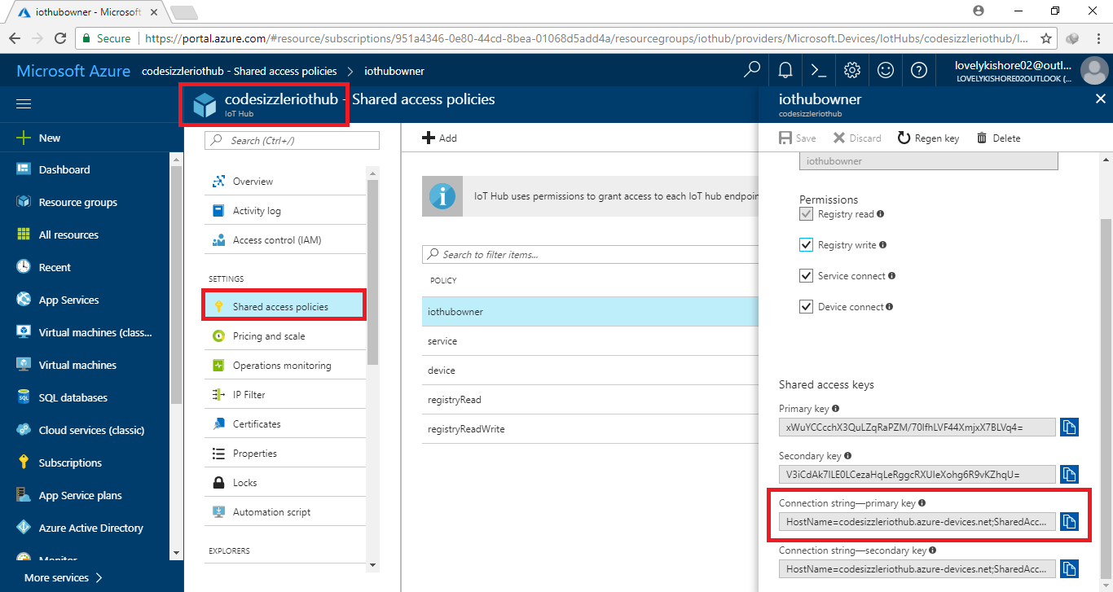

Finally, get back to the Program.cs page of your solution and paste the below given code. Make sure to add your EventHub connection string, Event hub name from which you are going to receive the messages, Storage Account name in which the messages are going to be stored and the key of your storage account that you copied previously.

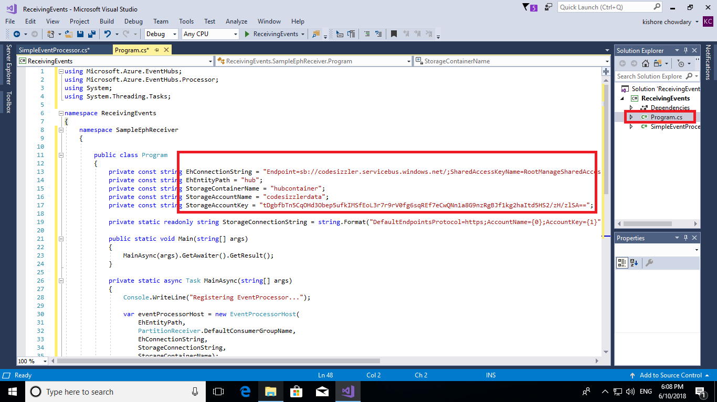

**Program.cs:**

namespace SampleEphReceiver

{

public class Program

{

private const string EhConnectionString = "{Event Hubs connection string}";

private const string EhEntityPath = "{Event Hub path/name}";

private const string StorageContainerName = "{Storage account container name}";

private const string StorageAccountName = "{Storage account name}";

private const string StorageAccountKey = "{Storage account key}";

private static readonly string StorageConnectionString = string.Format("DefaultEndpointsProtocol=https;AccountName={0};AccountKey={1}", StorageAccountName, StorageAccountKey);

public static void Main(string[] args)

{

MainAsync(args).GetAwaiter().GetResult();

}

private static async Task MainAsync(string[] args)

{

Console.WriteLine("Registering EventProcessor...");

var eventProcessorHost = new EventProcessorHost(

EhEntityPath,

PartitionReceiver.DefaultConsumerGroupName,

EhConnectionString,

StorageConnectionString,

StorageContainerName);

// Registers the Event Processor Host and starts receiving messages

await eventProcessorHost.RegisterEventProcessorAsync<SimpleEventProcessor>();

Console.WriteLine("Receiving. Press ENTER to stop worker.");

Console.ReadLine();

// Disposes of the Event Processor Host

await eventProcessorHost.UnregisterEventProcessorAsync();

}

}

}

After all the changes are made, press **F5** button or hit the run option at the top to execute the code. You will receive messages from the event hub to your storage account.

